Ecovi serial port debug system——ESP
Installation and use manual

无锡艾柯威科技有限公司2010-2011版权所有
Copyright ©2010-2011 by ECOVI Technology Co.,Ltd.

1. Installation 3
2. Use 3
2.1 Main Interface 4
2.2 SerialPort Configuration 5
2.3 Washing machine[Debug] 6
3. Examples of device connection 7
4. Recommendation for protocol of use 7
4.1 DD protocol 8
4.2 ESP protocol 8
4.3 ECOVI_OLD protocol 9

- Installation
- Decompression
- In order to improve the speed of installation, for computers that have never installed .NET Framework, it is recommended to unzip ESP.rar to any location you choose and double-click “setup.exe” in the folder as followed.
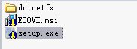
- Installing
- Click “Next” and choose a location to install the files. The default location, “C:\Program Files\ECOVI\ESP\”, is recommended. Then click “Next”.
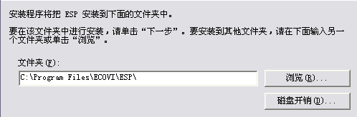

- Computers without .NET Framework need to spend some time extracting the necessary files from ESP. Installing time is about 1 minute. Please be patient.
- Desktop will appear an icon after the completion of installing, double-clicking the icon will lead to running ESP which is showed in figure.

- Use
ESP basic features
- Integrated serial port assistant and communication protocol. Be able to send and receive instructions , including configure the serial port.
- Be able to send instructions relevant to protocol by opening configure files and modify communication by changing configure files.
- Simulation of washing process of wash –machine and setting parameters.
- Build-in counter timer. You can open it in need.
- Adding ECC and operation.
- Main Interface
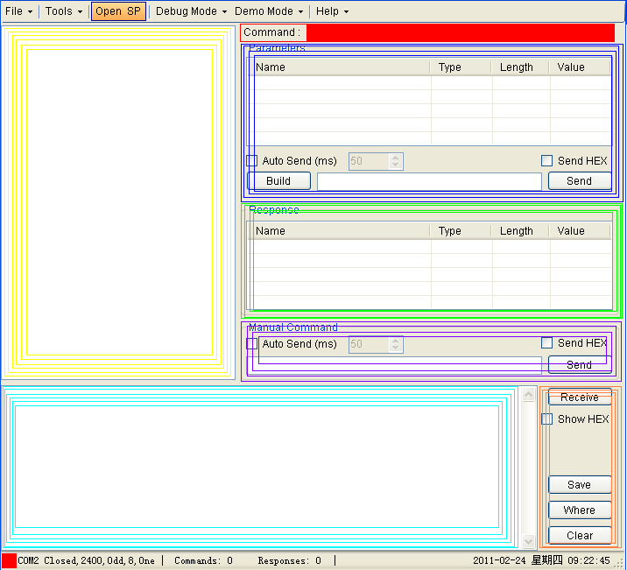
  区域 | 说明
  最上区域： | 菜单栏;
  黄色区域： | 指令列表；
  红色区域： | 当前选择指令；
  蓝色区域： | 选择指令的 参数、生成、发送、自动发送、十六进制和ASCII码的切换；
  绿色区域： | 选择指令的返回参数；
  紫色区域： | 用户输入值、发送、自动发送、十六进制和ASCII码的切换；
  青色区域： | 接收到的值；
  棕色区域： | 接收的十六进制和ASCII码的切换、保存接收值、打开保存文件夹、清除接收值；
  最下区域： | 当前串口的状态、串口的配置、接收和发送的指令数、当前的日期和时间

- Menu

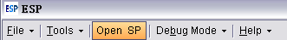

It includes “File”, “Tools”, ”Open SP”, “Debug Mode”, “Help” from left to right.

- “File”

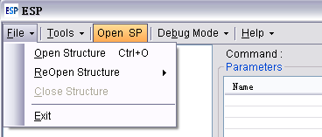

The “file” menu includes “Open Structure”, “ReOpen Structure”, “Close Structure” and “Exit” from top to bottom

- “Tools”
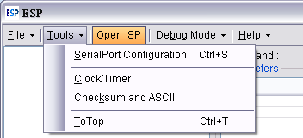

It includes “SerialPort Configure”, “Clokc/Timer”, “Checksum and ASCII” and “ToTOp”.

- “Debug Mode”

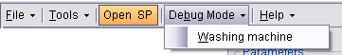

It includes “Washing machine”.

- “Help”

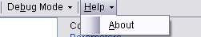

It includes “About”.
- SerialPort Configuration
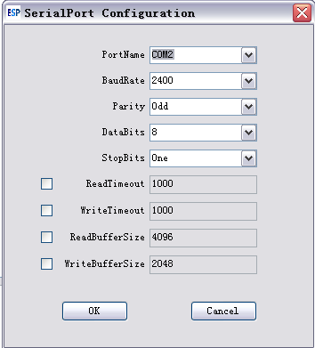
- It is recommended to set “ReadTimeOut” and “Write TimeOut” to 1000 to avoid suspended animation.

- Washing machine[Debug]
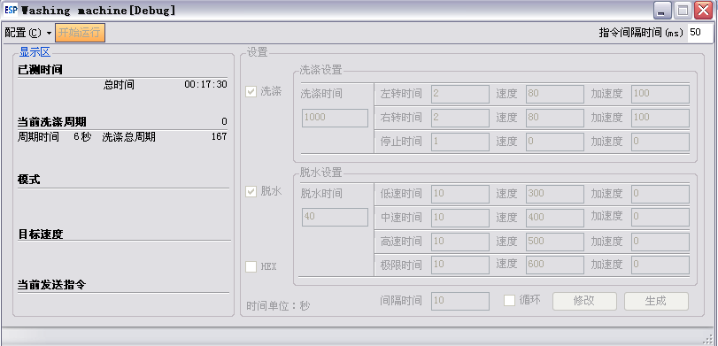

- Configuration of Washing machine[Debug]

- Click Configure->Open Configure and choose configure files(The figure shows the ESP protocol of Ecovi).

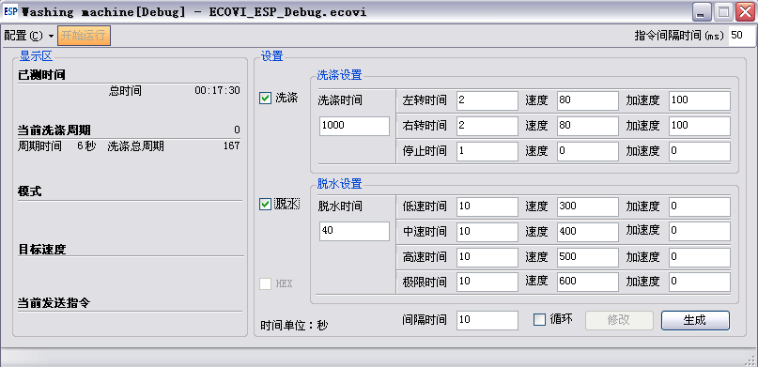

- Run of Washing machine[Debug]

- In setting area, choose washing or dehydration and parameters of cycle running under setting area.

- Stop of Washing machine[Debug]
- Click “Generate” after setting parameters, click “change” if modify is needed.,Then click “Start”. Debug will send instructions itself.
- Click “Stop” when stop the debug , and click “OK”; If “stop” does not work, please click “Running” again ,then click “stop”.
- Examples of device connection

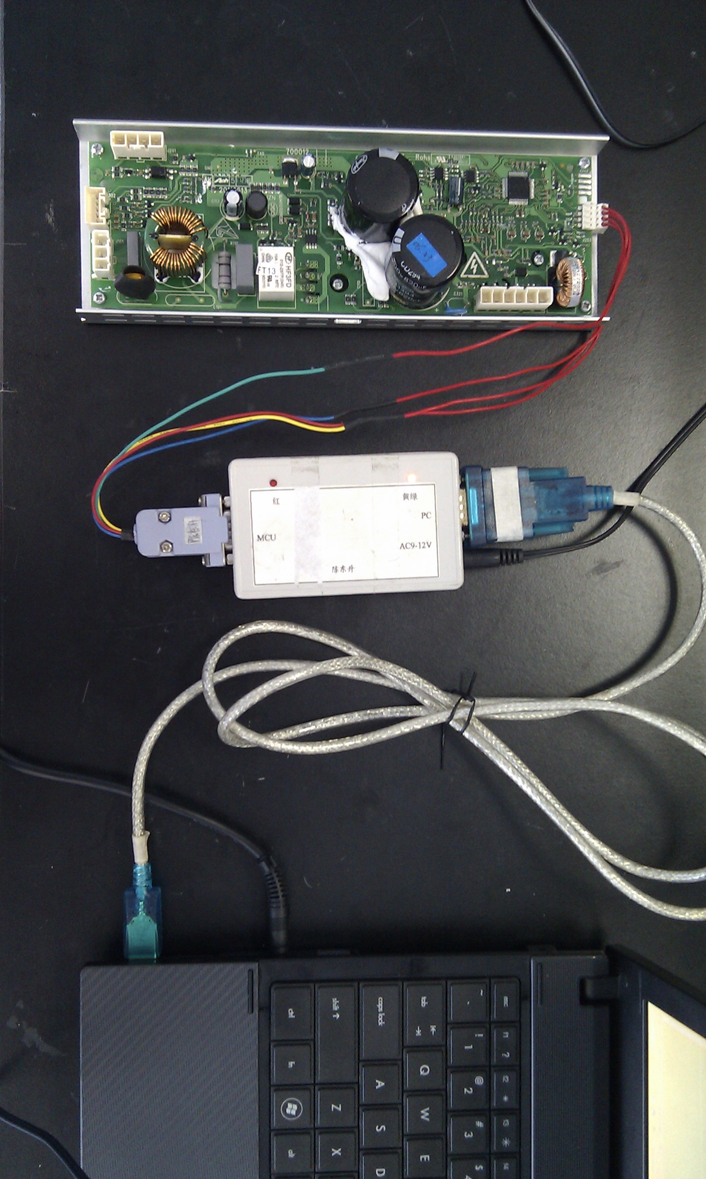
Through the line of USB-to-Serial Port, a PC connects to the communication box, whcih communicates with VFD(Variable-frequency Drive), as shown in figure above.
- Recommendation for protocol of use
You can choose Washing, Dehydration, Cycling in the interface of simulation procedure.
If Washing is only choosed, it is advised that you send instructions as the order of stop, turning left, stop, turning right;
If Dehydration is only choosed, it is advised that you send instructions as the order of low speed, speed, high speed, and maximum speed;
If Washing and Dehydration are choosed both, dehydrate after washing;
If Cycling is only choosed, do it again after a while.

4.1 DD protocol
·Click File->Open Structure in main interface, and DD.xml will be opened.

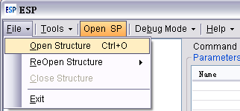
DD.xml includes the configures of DD project, Baud Rate is set as 2400bps default and odd check is loaded.
·Debug Mode->Washing machine in simulation procedure
Click Configure->Open Configure, and choose DD Debug.ecovi, time unit is seted to second, but acceleration is free to modify.
The next step is to click Generate->Start running. Ater doing this, the button of Start running is changed to Stop running automatively.
If you need to stop the procedure, click Stop running and Ok following.

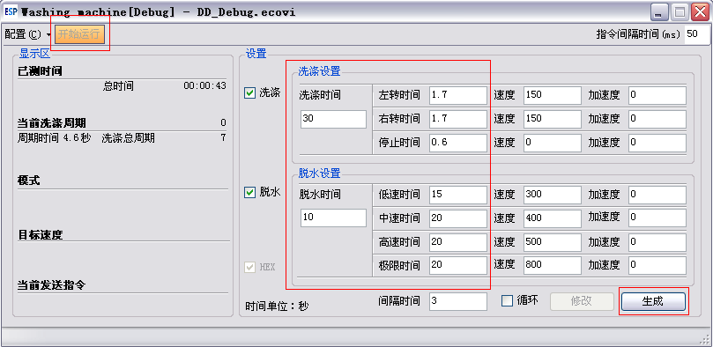

4.2 ESP protocol
·Click File->Open Structure in main interface, and choose ECOVI_ESP.xml.
ECOVI_ESP.xml does not contain the configure of project. The setting of Baud Rate and Check should follow the need. The approach is to click Tools->SerialPortConfiguration to configure.
The Baud Rate of DD project and Check is set to 2400bps and odd respectively.
The Baud Rate and Check of Viano_A1 is 2400 and None.
The Baud Rate and Check of Viano_A2 is 2400 and None.
The Baud Rate and Check of Viano_W1 is 9600 and None.
·Debug Mode->Washing machine
Click Configuration->Open configuration, and choose ECOVI_ESP Debug.ecovi, time unit is set to second; acceleration can be modified.
The next step is to click Generate->Start running. Ater doing this, the button of Start running is changed to Stop running automatively.
If you need to stop the procedure, click Stop running and Ok following.

4.3 ECOVI_OLD protocol
·Click File->Open Structure in main interface, and choose ECOVI_OLD.xml.
ECOVI_ OLD.xml does not contain the configure of project. The setting of Baud Rate and Check should follow the need. The approach is to click Tools->SerialPortConfiguration to configure.
The Baud Rate of DD project and Check is set to 2400bps and odd respectively.
The Baud Rate and Check of Viano_A1 is 2400 and None.
The Baud Rate and Check of Viano_A2 is 2400 and None.
The Baud Rate and Check of Viano_W1 is 9600 and None.
·Debug Mode->Washing machine
Click Configuration->Open configuration, and choose ECOVI_ OLD Debug.ecovi, time unit is set to second; acceleration can be modified.
The next step is to click Generate->Start running. Ater doing this, the button of Start running is changed to Stop running automatively.
If you need to stop the procedure, click Stop running and Ok following.

